PRACTICAL NO. 4

Digital Signatures: Implement digital signature algorithms such as RSA-based signatures, and verify the integrity and authenticity of digitally signed messages.

Server Code:
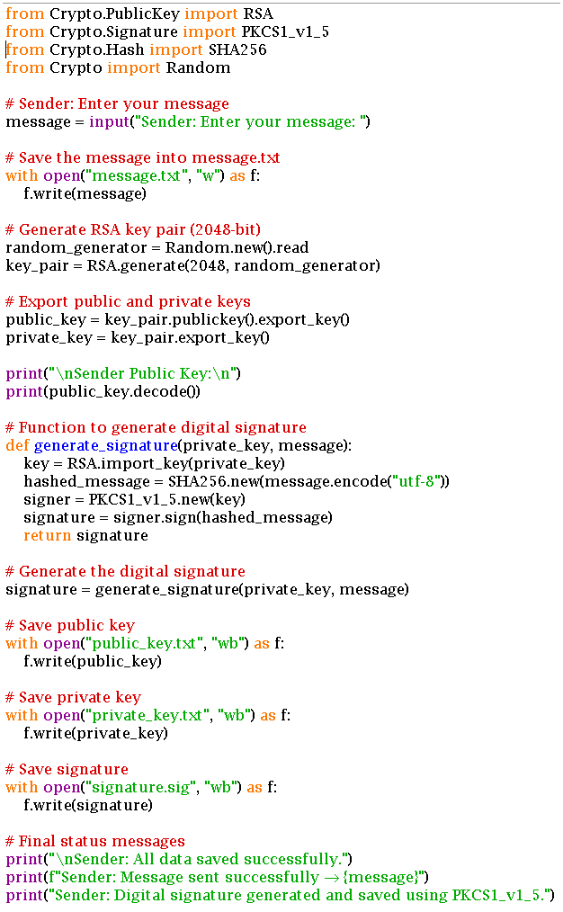

Client Code:
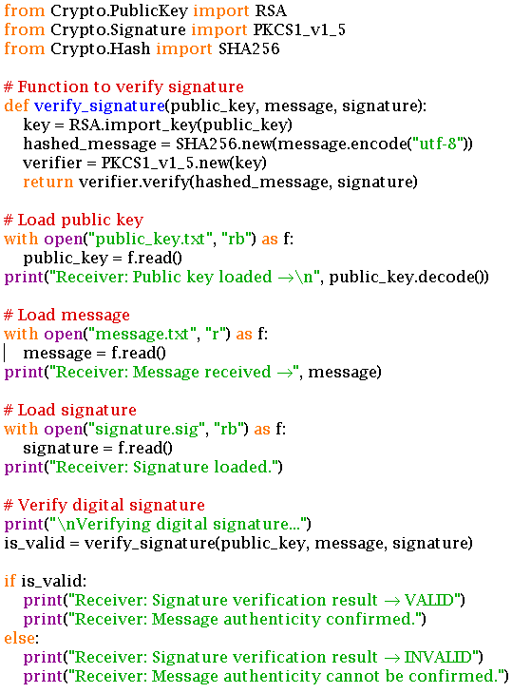

Server Output:
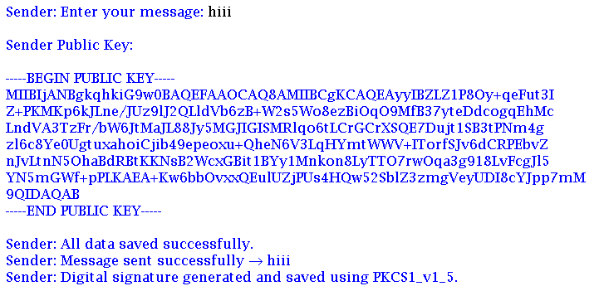

Client Output:
